Vision on NATO’s Common Cross Community of Interest Semantic Reference Model

# References

1. AC/322-D(2015)0001-COR1-FINAL, NATO Core Data Framework – a Vision for Data Interoperability, 13 March 2015
2. APP-15 Edition A Version 3 (Covered by STANAG 2519 Edition 1), NATO Information Exchange Requirement Specification Process, 5 June 2020
3. ADatP-3 Database (NATO Source for APP-11 Edition D Version 1 (Covered by STANAG 7149 Edition 6) – NATO Message Catalogue, 23 November 2015)
4. AAP-03 Directive for the Production, Maintenance and Management of NATO Standardization Documents, Edition K Version 1, 28 February 2018
5. MIP Information Model (Covered by STANAG 5643 Ratification Draft (RD) 2)
6. STANAG 5653 NCDF Study Draft
7. AC/322(CP/1)N(2019)01 09 (INV), Bi-SC MTF Development, Information Sharing and Transformation Strategy (MTF DISTS)
8. C3 Standards Engineering Procedures (C3 StEPs), NATO Information Exchange Specification Development Process (Draft)

# Vision

1. An overarching process established in NATO using a common agreed semantic reference model in order to streamline the development of information exchange requirements and specifications as well as to enable interoperability by harmonization at design time, whilst under the supervision of all involved NATO bodies by the Military Committee, is in place effective as of year 2028.

# Background

1. In order to enable the required interoperability, standardization bodies make huge efforts to specify unambiguous technical solutions, data formats, and the exchanged information. The NATO Core Data Framework (NCDF, Ref A) envisions addressing these specifications separately to increase likelihood of reuse. Based on lessons learned in standardization and modelling, the NCDF utilizes an overarching model to unambiguously capture the semantics in a machine-processable format that is easy to understand and apply.
2. That overarching model, the **Common Cross Community of Interest Sematic Reference Model** (CXCSRM), is a core element of the NCDF Sematic Resource Repository, which includes semantic resources from operational domains (e.g. Air, Land, Maritime) and functional domains (e.g. JISR, Logistics, Medical), as depicted in Figure 1 below. The CXCSRM will represent a common language required to enable cross-community information exchange: While concepts relevant to more than just one domain need to be harmonized and become elements of the CXCSRM, existing domain specific semantic reference models and resources will continue to serve their purpose within the domain. However, in the long term these domain specific models should gradually be harmonized as well.

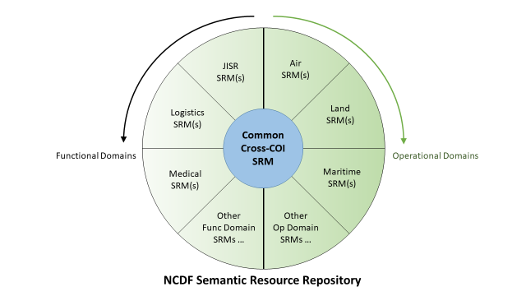

Figure 1 – Common Cross-COI SRM & NCDF Semantic Resource Repository

# Aim

1. The aim of this document is to outline an overarching process for NATO in order to streamline the development of Information Exchange Requirements (IERs) and Specifications (IESs) as well as to enable interoperability through harmonization at a design time by using the CXCSRM as the key enabler.
2. Furthermore, it is foreseen to demonstrate the initial applicability of using the CXCSRM during IES development and to use the CXCSRM for the harmonization of existing NATO information exchange standards, such as defined by the ADatP-3 Database (Ref. C), and non-NATO information exchange standards.
3. The development of new IESs (e.g. for new communities of interest or domains like “Space”) based on the CXCSRM is also a mid- to long-term goal.

# SCOPE

1. In order to implement the vision and to achieve the aim, the CXCSRM needs to be introduced during the development of IERs, the NATO IER Specification Process as defined in APP-15 (Ref. B) need to be adapted accordingly.
2. The Multilateral Interoperability Programme (MIP) Information Model (MIM) provides a semantic foundation for joint Command and Control (C2) information exchanges with focus in the land domain (Reference E). Common joint concepts of the MIM are to be adopted as the initial parts of the CXCSRM. After the initial CXCSRM has been established, MIP and NATO agree to further cooperate to keep the MIM and the CXCSRM harmonized. A more detailed description of the term “SRM” and the MIM is at Appendix 1.

# Adapted IER / IES Development Process

1. The required and fundamental change to the NATO IER Specification Process as defined in APP-15 (Ref. B) is the involvement of the CXCSRM: Either re-use already defined CXCSRM information elements or otherwise develop new CXCSRM information elements while considering quality assurance and NATO terminology. Ultimately, the CXCSRM will contain a complete representation of all common information elements and their semantic references available to all actors involved in the process.
2. A detailed description of the adapted process and the required changes is at Appendix 2. The key additional sub-processes at different process steps include:
   1. Engage directly with CXCSRM experts to describe doctrinal or operational requirements and information in terms of CXCSRM information elements;
   2. Align the Draft IER with concepts, information elements, and terminology from the CXCSRM. Extend the CXCSRM as required;
   3. Harmonize the Refined IER with concepts, information elements, and terminology from the CXCSRM. Extend the CXCSRM as required;
   4. Appropriate bodies to use their resources (and toolchains) to create the IES(s) from the IER that is already harmonized with the CXCSRM.

# Governance & Management

1. The adapted IER / IES development process as well as the maintenance of the CXCSRM require proper direction and guidance. While governance and management aspects need to be laid out in detail, the following assumptions and stipulations are to be considered:
   1. The Military Committee (MC) as Tasking Authority provides the governance over the CXCSRM, initializes the Standardization Task (ST) for MIM, and tasks the adoption of common joint MIM concepts as initial parts of the CXCSRM.
   2. The MC Joint Standardization Board (MCJSB) as Delegated Tasking Authority and the Harmonization Working Group (IERHWG) as Harmonization Authority shall make use of the CXCSRM and adopts the APP-15 process accordingly. The NATO Standardization Office (NSO) will support the activities.
   3. The NATO nations represented in the Consultation Command and Control Board (C3B) will provide the required CXCSRM technical expertise and should invite the MIP/MIM community for coordination and collaboration.
   4. The MC provides necessary funding to perform the CXCSRM harmonization, development, and maintenance.
   5. The MC assigns a NATO license and confidentiality label to the CXCSRM and its content.
   6. The CXCSRM contains only non-classified (NU) semantic concepts, while classified concepts might be contained in contributing domain-specific semantic reference models.
   7. The MC assigns a custodian for the CXCSRM and its maintenance.
   8. *NATO and MIP MoA support and approval (placeholder)*
   9. Governance guidance among related and impacted reference documents (e.g. references B, C, F, and H) must be harmonized to ensure consistency.

# RESOURCES and Other Requirements (“DOTMLPFI[1]”)

1. Doctrine. The outlined changes to APP-15 need to be applied. Governance, management, and administrative aspects of the CXCSRM are to be laid out in detail. Terms of References and agendas of impacted working groups need to be reviewed.
2. Organization. A new CXCSRM Panel or Syndicate will be created under the IERHWG. See Personnel aspects for manning.
3. Training. There are no specific training resource requirements at this time. Nevertheless, training on the post is required and it is envisioned and recommended to establish official training courses at NATO schools.
4. Material. For developing, maintaining, and harmonizing the CXCSRM, an appropriate amount of software licenses for enabling tools will be required.
5. Leadership. There are no specific leadership requirements at this time, other than supporting this vision and its implementation by nations and NATO bodies starting from MC, C3B, NSO throughout the various capability panels and teams.
6. Personnel. A rough initial estimate of the required skilled resources (potentially partial and/or double-headed with already existing SME) for the new CXCSRM Panel or Syndicate is 4-5 Full Time Equivalents (FTE) CXCSRM experts (data/information modellers). The estimate is based on the considerations below. Partial participation (as workload requires) is favoured:
   1. Currently identified relevant meetings (might need de-confliction):
      * IERHWG – 2 times per year, 4-5 days
      * All IER Panels
        + SJIERP – 2 times per year, from 2 days to 1 week
        + SAIERP – 2 times per year, 2 days
        + SMIERP – 2 times per year, 1 week
        + SLIERP – 2 times per year
      * Special/Functional IER Panels - 10-15 / year 3-5 days
      * DM CaT – 3 times per year, 4-5 days
      * MTF CaT – 3 times per year, 4-5 days
      * TDL CaT XML Syndicate – 3 times per year, 1-2 days
   2. It is proposed that the new CXCSRM Panel or Syndicate will be formed/manned with nations and Bi-SC providing representatives, ideally from the working groups and syndicates listed above. They are to develop and maintain the harmonized CXCSRM in synergy with other relevant NATO or non-NATO bodies:
      * MIP Working Group (WG) – 4 times per year, 2 weeks
      * Between MIP WGs – 3 times per year, 1 week (as deemed necessary, maybe virtually) – to address specific NATO requirements (MIP not obliged to attend)
7. Facility. There are no specific facilities requirements at this time.
8. Interoperability. There are no specific interoperability requirements at this time.

# Way Ahead

1. In order to implement this vision, all “DOTMPLFI” aspects need to be laid out in detail. The following are recommended as first steps:
   1. The MC to foster the finalization of the Standardization Task (ST) to standardize the MIM (as STANAG 5643, reference E) and to adopt common joint MIM concepts as initial parts of the CXCSRM.
   2. The MC to assign a custodian for the CXCSRM.
   3. The DM CaT and the MTF CaT (as authors of this vison)
      * to establish an interim CXCSRM Syndicate under the DM CaT,
      * to lay out detailed concepts (concept of operation) to manage, administer and harmonize the CXCSRM in cooperation with the IERHWG.
   4. The IERHWG to establish a CXCSRM Panel replacing the DM CaT’s interim NATO SRM Syndicate.
   5. The C3B and the NSO to establish an agreement for cooperation and collaboration between MIP and NATO.
2. Future harmonization work in NATO should be planned in 3 stages:
   1. Stage 1. The harmonization between ADatP-3 database and CXCSRM is initiated and the APP-15 process is integrated as a pilot in accordance with the mandate from C3B and NSO.
   2. Stage 2. The pilot study is extended to the other data standards within NSO and C3B area of responsibility.
   3. Stage 3. Enlarging the harmonization work to the other standards under the responsibility of other Authorities (Technical, Operational, etc.) at NATO.

Appendix 1 – Description of SRM and MIM

# NCDF & SRM

1. The NCDF envisions addressing the technical solutions, data formats, and exchanged information separately to increase likelihood of re-use. Based on lessons learned in standardization and modelling, the NCDF defines an overarching model to unambiguously capture the semantics in a machine-processable format that is easy to understand and apply. This model serves as semantic reference for the specification of information exchange requirements (i.e. it provides the “vocabulary” to describe the IERs) and the description of IES (i.e. it is the starting point for the IES development process).

# Advantages & Disadvantages of SRM USAGE

1. Advantages. A Common Cross Community of Interest Semantic Reference Model (CXCSRM) ensures common description and understanding of concepts being used by several “domains” or Community of Interests (COI) within the NATO Enterprise, among the Alliance, and with coalitions/federations.
2. By utilizing the model driven approach, it provides automation with its toolset, supports the user in the representation of concepts in their projects, and supports the cooperation of operational and technical experts discussing data and information elements.
3. Disadvantages. The CXCSRM usage adds overhead in the beginning with a return of investment in the mid-/long-term. It requires resources to use and maintain the SRM as well as initial training.

# The CXCSRM and the “MIM”

1. MIM is an information model providing semantic foundations for Command and Control (C2) information exchange with focus in the Land domain. Its scope is defined by military information exchange requirements for multiple echelons in joint/combined operations. It can be easily extended to model information from different domains (e.g. air, logistic) and will provide common joint concepts as the foundation and starting point of the CXCSRM.
2. MIM is developed following the Model Driven Architecture concepts and for this reason it is platform-independent, i.e. it is not limited to a specific exchange technology, and supports the efficient development of data exchange schemas. At the same time, as a semantic reference model, the MIM enables communication between and among operational subject matter experts and system engineers.

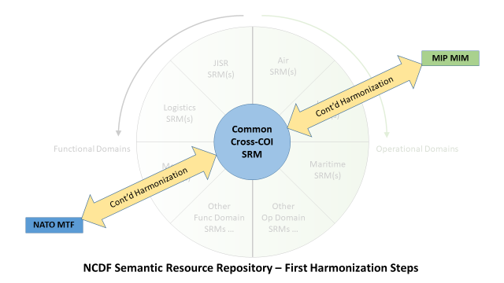

Figure 1-1 – First Harmonization Steps

1. The initial and continuous harmonization steps after the establishment of the CXCSRM will be (1) with future APP-11 NATO Messages currently based on NATO Message Text Formats (MTFs). This harmonization will be based on the adapted APP-15 process and (2) with MIP/MIM based on a MIP-NATO agreement. See depiction at Figure 1-1 above.

Appendix 2 – Adapted IER / IES Development Process

# Introduction

1. The fundamental change to the IER specification process is the involvement of the CXCSRM: Either re-use already defined CXCSRM information elements or otherwise develop new CXCSRM information elements while considering quality assurance and NATO terminology. Ultimately, the CXCSRM will contain a complete architecture in which all common cross-COI or cross-domain information elements and their semantic references are available to all actors involved in the process.
2. The following describes the NATO IER Specification Process as defined in APP-15 Edition A Version 3 along with the required changes.

# Adapted NATO IER SPECIFICATION PROCESS

## IR Development (Step 1) Process Initiation – APP-15 Section 2.1.4.

Change. Rephrase 2. to:

## The information necessary to process the requirement should be provided with direct engagement of CXCSRM experts as complete and accurate as possible using the template provided in Annex C.Draft IER Development (Step 2) – APP-15 Section 2.1.5.

* Change. Reprase 2.a.
* to confirm that the IR is not satisfied by an existing IER or CXCSRM
* Change. Rephrase 2.b.(1) to “supplementing the necessary information of the IR (**with CXCSRM experts** and support of the IR originator as required).”
* Change. Rephrase 3. to “When refining the IEs and drafting the DEs, support can be provided by the NHQC3 Staff and **CXCSRM experts** to the functional IER Panel, in order to enable reuse of existing elements (*Paragraph 2.1.10 – Data Harmonization refers*).”

## Refined IER Development (Step 3) – APP-15 Section 2.1.6.

* Change. Rephrase 1.a. to “Validate the IER meets the operational requirement form the single service perspective **and CXCSRM adaptation**. For IERs developed outside the MC the validation will be performed by the SJIERP by checking across all domains.”
* Change. Rephrase 2. to “When refining the IEs and DEs, support can be provided by the NHQC3Staff **and CXCSRM experts** to the Senior IER Panel in order to enable reuse of existing IEs and DEs and identify potential harmonization tasks. (Paragraph 2.1.10 Data Harmonization refers).”

## Finalised IER Joint Validation (Step 4) – APP-15 Section 2.1.7.

* Change. Rephrase 2.b.
* Forward the refined IER to the Technical Authority and CXCSRM experts for technical assessment.

## IES(s) Development (Step 5) – APP-15 Section 2.1.8.

* Change. Add 1.c.
* Appropriate bodies to use their resources (and toolchains) to create the IES(s) from the IER that is already harmonized with the CXCSRM.
* Change. Add 1.d.
* Appropriate bodies to validate, verify, and review the toolchains’ output (IES(s)) with respect to the used standards.
* Note. The NATO MTF community as represented by the MTF CaT as one of the NATO IES development bodies has already committed to the adoption of the CXCSRM as outlined within the Standard Related Documents (SRD) under the cover of STANAG 5653 - NCDF Governance (Ref. F).

## Solution(s) Publication (Step 6) – Process Termination – APP-15 Section 2.1.9.

* No changes expected.

## Data Harmonization – APP-15 Section 2.1.10.

* Change. Rephrase 1. to “One of the objectives of data harmonization is to maximise the reuse of existing data **and semantics.**“

Appendix 3 – TERMS AND DefinitionS

* **Data Harmonization**: Data harmonization is the process of comparing two or more data component definitions and identifying commonalities among them that warrant their being combined, or harmonized, into a single data component.
* **Data Mediation**: Data mediation, also referred to as data transformation, is the conversion of data from a source data format to a destination data format. It generally occurs in two steps: (1) Mapping data elements from source to destination, and documenting any required transformation; and, (2) code generation which creates the transformation program.
* **Information Element (IE):** The factual content of information described by terms referring to specific concepts with their unique characteristics and relationships, (Source: NATOTerm, The Official NATO Terminology Database).
* **Information Requirement (IR):** An operational statement that describes the need to provide or consume one or more information elements, supplemented by meta-information that comprehensively describes the operational need for, as well as when and how the information is provided or by whom it is needed, (Source: NATOTerm).
* **Information Exchange Requirement (IER):** A finalized, harmonized and detailed operational expression of an information requirement, complemented by other operational constraints, that allow appropriate technical solutions to be identified and designed, (Source: NATOTerm).
* **Information Exchange Specification (IES):** A comprehensive and detailed description of the translation of an information exchange requirement into a specific technical solution, including appropriate justifications.

Notes: As the information exchange specification links operational requirements to technical details, the impact of technical changes on operational requirements and vice versa becomes traceable (Source: NATOTerm).

* **Harmonization:** Within the context of this document: It is the operation to compare two set(s) of data or information objects between NATO SRM and a NATO data or information standard; e.g., ADatP-03 with the aim to match/align the description/representation in that NATO standard with the one in SRM. This operation creates a linkage between the related data and information objects and ensures that both descriptions are made the same by doing necessary changes.
* **Model:** A limited representation of the real world. Models have three important properties: they are reproducing (i.e., they describe something, there is a real-world matchable concept), they are limited (not all properties are reproduced), and they are pragmatic (models map to reality only for specific purposes; there is no use in modelling properties that do not contribute to the intended use).
* **Semantic Reference Model (SRM):** The SRM provides a common language (and structure) to be used during operations and exercises. It captures the meaning of the information to be exchanged between many different systems. It is used as the common language to translate between the operational world (where IERs are defined) and the more formal technical world (where the IESs are specified). It is the conceptual and high level logical model to describe concepts relevant to the operational world (Source: SRM Concept Paper, NCDF).
* 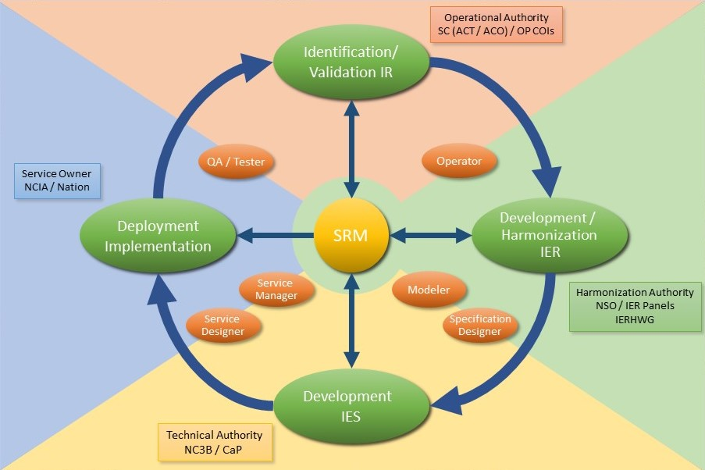**SRM Vision Process Cycle:** It is a 4 phase process cycle to specify the use the SRM at NATO. The four phases form a cycle which connects the end of Phase 4 to Phase 1 where the operator controls/compares the implementation to systems in use with the doctrine and/or operational requirement stated at the beginning of the cycle and decides if the cycle needs to be restarted or not, (Defined by SRM Vision Process Workshop).

Appendix 4 – List of abbreviations

ACT: Allied Command Transformation

ADatP-03: Allied Data Publication Number 3 (MTF Specification)

CaT: Capability TeamCaP: Capability Panel

CXCSRM: Common Cross Community of Interest Semantic Reference Model

ICT: Information and Communication Technology

IE: Information Element

IR: Information Requirement

IER: Information Exchange Requirement

IERHWG: IER Harmonisation Working Group

IES: Information Exchange Specification

MC: Military Committee

MIP: Multilateral Interoperability Programme

MTF: Message Text Format

NCDF: NATO Core Data Framework

NSO: NATO Standardization Office

SRM: Semantic Reference Model

1. Doctrinal, Organizational, Training, Material, Leadership, Personnel, Facility, Interoperability